**In this Update:**

* **Cambria County Paid Work Experience End of Summer Ceremony**
* **Pennsylvania Grain Processing Open House**
* **Clearfield County Farm Bureau Legislative Farm Tour**
* **Commercial Vehicle Safety Symposium**
* **Langerholc Visits the Learning Station Child Development Center**
* **PennDOT Offers Winter Maintenance Jobs**
* **Free Webinars Provide Helpful Financial Aid Info**
* **How Pennsylvanians with Disabilities Can Benefit From PA ABLE**
* **~~Free Pools and Lakes Open at State Parks~~**
* **Recognizing National Financial Awareness Day**

## Cambria County Paid Work Experience End of Summer Ceremony

(PWE.PNG)

Last week, I had the pleasure of speaking at the Cambria County Paid Work Experience (PWE) program’s End of Summer Ceremony. By partnering with Goodwill and the PA Department of Labor and Industry’s OVR, the PWE program provides young adults with valuable workplace exposure and experience.

## Pennsylvania Grain Processing Open House

(Grain Processing.png)

Last Friday, I attended the open house of Pennsylvania Grain Processing (PGP) in Clearfield alongside Congressman GT Thompson, Representative Dallas Kephart, and Representative Mike Armanini.

## Clearfield County Farm Bureau Legislative Farm Tour

(clearfield farm bureau)

This week, my staff attended the Clearfield County Farm Bureau’s Legislative Farm Tour at Leonard Farm in Frenchville.

## Commercial Vehicle Safety Symposium

(commercial vehicle safety)

I was honored to speak at the 2024 Commercial Vehicle Safety Symposium at the Toftrees Golf Resort in State College this week.

## Langerholc Visits the Learning Station Child Development Center

(learning station)

This week, I had the pleasure of touring the Learning Station School, a child development center located in Ferguson Township, Centre County. Thank you to the educators and staff for their tireless commitment to providing quality education to our young children and thank you to the preschool class who listened to my reading of The Cat in the Hat!

## PennDOT Offers Winter Maintenance Jobs



Individuals seeking seasonal employment can apply for a variety of winter maintenance positions now open through the Pennsylvania Department of Transportation (PennDOT).

The program runs September through April and includes positions for transportation equipment operators, diesel and construction equipment mechanics, radio dispatchers, auto mechanics, tradesman helpers, semi-skilled laborers and tunnel maintainers. Individuals in these positions supplement the permanent workforce and have the potential to lead to permanent full-time employment.

Additional details about the positions, along with the job application, are available [here](https://www.governmentjobs.com/careers/pabureau?department%5b0%5d=Department%20of%20Transportation&sort=PositionTitle%7cAscending) and then go to “PennDOT Winter Maintenance Program.”

## Free Webinars Provide Helpful Financial Aid Info



The Pennsylvania Higher Education Assistance Agency (PHEAA) is holding free webinars to assist college-bound students and their families with navigating the financial aid process.

On Tuesday, Aug. 20 at noon, speakers will discuss web resources for effective research before, during and after your student makes postsecondary decisions. On Thursday, Aug. 22 at 6:30 p.m., speakers will focus on available loan programs, if there are costs not showing on the bill that must be paid and more.

[Register to attend](https://www.pheaa.org/virtual/) the one-hour webinars.

## How Pennsylvanians with Disabilities Can Benefit From PA ABLE



PA ABLE gives individuals with disabilities a way to save money for the future without impacting important benefits like Medical Assistance (Medicaid) or Supplemental Security Income (SSI).

Tax benefits for saving with PA ABLE include:

* Contributions are deductible from PA state income taxes.
* Earnings and contributions grow tax-free.
* No taxes are owed for qualified withdrawals.
* Accounts aren’t subject to the state inheritance tax.

PA ABLE accounts can be used to pay for a wide variety of disability-related expenses including rent, groceries, health care, vehicle adaptations, assistive technology and more. Treasurer Stacy Garrity and PA ABLE professionals are hosting free webinars on how to start saving:

* Monday, Aug. 12 at 2 p.m.: [ABLE Accounts 101](https://streamyard.com/watch/rZArypkHJwkV)
* Tuesday, Aug. 13 at 6 p.m.: [Learn About PA ABLE](https://events.gcc.teams.microsoft.com/event/87b2c7d9-1ddb-4f02-810b-7484520ed8db@aff0f5b6-7ab3-4f66-b46c-0b7d250ad998)
* Wednesday, Aug. 14 at 2 p.m.: [How Can Employers Promote ABLE as an Accessibility Tool?](https://us06web.zoom.us/webinar/register/WN_YxUmJBnqSOO50uBoH3-3WA#/registration)
* Wednesday, Aug. 21 at 2 p.m.: [I Have an ABLE Account, Now What?](https://us06web.zoom.us/webinar/register/WN_jsSdtR-aTmmB6V1LkyEtlQ?_x_zm_rtaid=SRZnasJKRSy5l_g8N1WO0A.1721306898257.d67fdfdae72cd366fd66477ca72336c3&_x_zm_rhtaid=373#/registration)

For more information, visit [paable.gov](https://paable.gov/) or call 855-529-ABLE (2253).

## ~~Free Pools and Lakes Open at State Parks~~

~~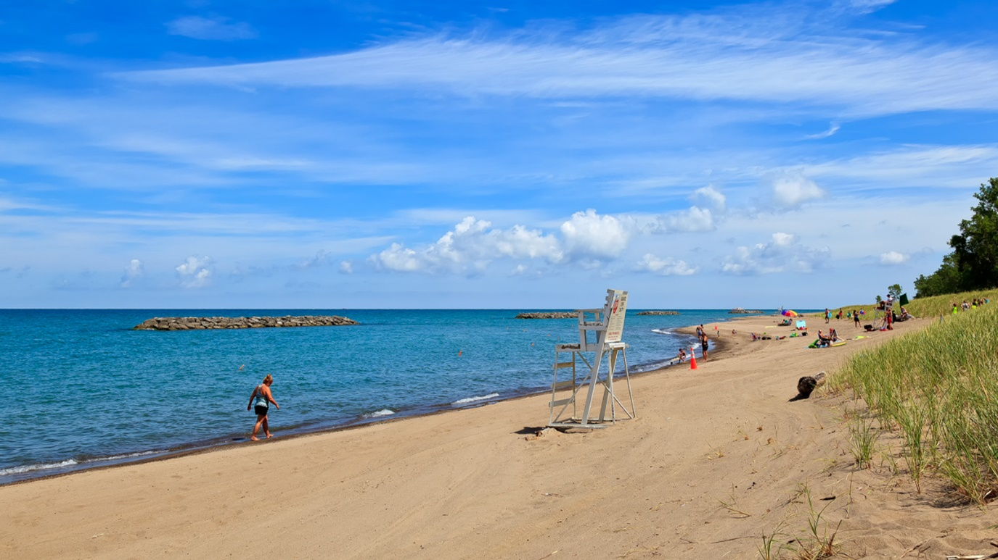~~

~~If you’re looking for a fun way to spend a summer day, visit a Pennsylvania state park to go swimming. Many have pools and lakes.~~

~~State park beaches are open and free to the public for swimming from before Memorial Day to after Labor Day, unless otherwise posted. The “open swim” policy allows people to swim at their own risk within the buoy line at designated beaches – 35 across the state – from 8 a.m. until sunset daily.~~

~~Fifteen state parks have swimming pools for the public to enjoy. Pools are usually open from Memorial Day weekend to Labor Day weekend, 11 a.m. to 7 p.m. daily. Admission fees vary based on the type of operation. Lifeguards are on duty when state park pools are open.~~ [~~Find a park with a pool~~](https://www.dcnr.pa.gov/Recreation/WhatToDo/Swimming/Pages/default.aspx) ~~and learn more.~~

## Recognizing National Financial Awareness Day



Wednesday, Aug. 14, marks National Financial Awareness Day. With recent estimates showing families in the United States have nearly $1 trillion in credit card debt and more than $15 trillion in debt overall, the day is a useful reminder of the impacts financial decisions can have for many years to come.

Senate Republicans recognized that young adults face financial decisions that can come with long-term consequences and passed [legislation](https://www.legis.state.pa.us/cfdocs/billInfo/billInfo.cfm?sYear=2023&sInd=0&body=S&type=B&bn=0647) to arm high school students with [money management skills](https://senatorgebhard.com/2023/12/13/gebhard-bill-to-improve-financial-literacy-set-for-enactment/). The new law requires completion of a half-credit personal finance course to graduate high school.

The course will give high school students the understanding they need about topics like credit and credit scores; savings and investments; college, home and auto loans; and planning for postsecondary education and retirement.